A Web-Based Order Management and Inventory Tracking System for Social Media-Driven Micro-Enterprises
SYSTEM DOCUMENTATION
SUBMITTED BY,
MOSES WANJIKU
ADM NO: DCS-01-8524/2024
A System Documentation Submitted in Partial Fulfilment for the Award of
Diploma in Computer Science
ZETECH UNIVERSITY
APRIL 2026

DECLARATION
I, Moses Wanjiku (ADM NO: DCS-01-8524/2024), hereby declare that this project titled “A Web-Based Order Management and Inventory Tracking System for Social Media-Driven Micro-Enterprises” is my original work. It has not been submitted for any other diploma or award at Zetech University or any other institution of higher learning. All sources of information used in this documentation have been duly acknowledged in the reference section.
Signature: _________________________
Date: 22/03/2026

DEDICATION
This project is dedicated to my family for their unwavering support, and to all micro-entrepreneurs striving to build their dreams through digital innovation.

ABSTRACT
This project presents the design and implementation of a centralized Order Management and Inventory Tracking System specifically tailored for social media-driven micro-enterprises. Many student entrepreneurs rely on manual processes via Instagram DMs, which leads to fragmented data, missed sales, and administrative errors.
The system was developed using a modern web stack including HTML5, CSS3, JavaScript, and Firebase Firestore for real-time cloud data storage. Key features include a secure login gateway, a business health dashboard, automated low-stock alerts, and an integrated order tracking workflow. The documentation covers the full Software Development Life Cycle (SDLC), from initial problem statement and modeling to implementation and deployment on Firebase Hosting. Results from testing indicate that the system significantly improves operational efficiency and data accountability for jewelry artisans.

DEFINITION OF KEY TERMS
- Artisan: A worker in a skilled trade, especially one that involves making things by hand; in this context, a jewellery maker.
- Database: A structured set of data held in a computer, especially one that is accessible in various ways.
- Inventory: A complete list of items such as raw materials (beads, clasps) and finished products currently in stock.
- Low-Code/No-Code: A type of software development that requires little to no coding to build applications.
- Recipe: A defined list of raw materials and quantities required to produce one specific piece of jewellery.
- Workflow: The sequence of industrial, administrative, or other processes through which a piece of work passes from initiation to completion.

ABBREVIATIONS AND ACRONYMS
Acronym | Meaning
API | Application Programming Interface
CSS | Cascading Style Sheets
DM | Direct Message (specifically referring to Instagram DMs)
ERD | Entity Relationship Diagram
GUI | Graphical User Interface
HTML | HyperText Markup Language
IDE | Integrated Development Environment
IT | Information Technology
JS | JavaScript
JSON | JavaScript Object Notation
NoSQL | Not Only SQL (referring to non-relational databases like Firestore)
SDLC | Software Development Life Cycle
UI | User Interface
UX | User Experience

LIST OF FIGURES
- Figure 2.1: Login Page Interface
- Figure 2.2: System Dashboard
- Figure 2.3: Order Management Interface
- Figure 2.4: Customer Message Management Interface
- Figure 2.5: Inventory Management Interface
- Figure 2.3.1: Login Process Flowchart
- Figure 2.3.2: Order Process Flowchart
- Figure 2.3.3: Payment Processing Flowchart
- Figure 2.3.4: Inventory Management Flowchart
- Figure 2.3.5: Customer Enquiry Flowchart
- Figure 2.6: Use Case Diagram
- Figure 2.7.1: System Flow Diagram
- Figure 2.7.2: Data Flow Diagram (Level 1)
- Figure 2.8: Entity Relationship Diagram (ERD)
- Figure 3.1: HTML and CSS Source Code for Login Interface
- Figure 3.2: System Dashboard Interface
- Figure 3.3: Inventory Tracking Interface
- Figure 3.4: JavaScript Logic for Firebase User Authentication

LIST OF TABLES
- Table 1.4: Functional Requirements Table
- Table 1.6: Project Schedule Breakdown

TABLE OF CONTENTS
DECLARATION
DEDICATION
ABSTRACT
DEFINITION OF KEY TERMS
ABBREVIATIONS AND ACRONYMS
LIST OF FIGURES
LIST OF TABLES
CHAPTER ONE: PROJECT PLANNING AND ANALYSIS
1.1 Statement of the Problem
1.2 Justification of the Study
1.3 System Objectives
1.4 Breakdown of Tools and Resources
1.5 Functional Requirements
1.6 Project Schedule Breakdown
CHAPTER TWO: DESIGN AND MODELING
2.1 Introduction to Modelling
2.2 User Interface Models
2.3 Logic Models
2.4 Entity Relationship Diagram (ERD)
CHAPTER THREE: SYSTEM IMPLEMENTATION
3.1 Introduction
3.2 User Interface Development
3.3 Logic Development
3.4 Testing
3.5 Deployment
CHAPTER FOUR: CONCLUSION AND RECOMMENDATION
4.1 Conclusion
4.2 Recommendation
REFERENCES

CHAPTER ONE: PROJECT PLANNING AND ANALYSIS
  - Statement of the Problem
The current reliance on manual management of handmade jewelry businesses through social media Direct Messages (DMs) presents several critical operational challenges for student entrepreneurs. Small-scale jewelry artisans are increasingly expected to provide rapid, transparent, and personalized services while managing growing volumes of customer and inventory data, yet many continue to rely on fragmented processes for order intake and stock tracking (Shopify, 2023). In the business context under study, customer information and order details are scattered across isolated chat logs that lack structure, limiting the entrepreneur’s ability to access a real-time view of business health. This fragmentation contributes to missed sales opportunities, prolonged fulfillment times, and an increased risk of administrative errors regarding payment verification and raw material levels (Wix Engineering, 2024).
Furthermore, the absence of an integrated Order Management and Inventory Tracking System poses challenges related to data accountability and scalability, as manual records are often unable to enforce the auditability required for sustainable growth (Laudon & Laudon, 2022). As order volumes increase, the continued reliance on manual DM-based management becomes unsustainable. This creates a clear need to design and implement a centralized Order Management and Inventory Tracking System to automate processes, reduce errors, and support informed business decision-making.

1.2 Justification of the Study
The development of the Order Management and Inventory Tracking System is justified by the increasing demand for efficiency and data integrity in the digital micro-enterprise sector. Automated systems have been shown to improve workflow efficiency and reduce administrative burdens by enabling real-time access to accurate stock and order information (Shopify, 2023).
Automating jewelry-specific processes—such as material tracking and order status updates—minimizes human error and prevents production delays caused by unforeseen stockouts. Furthermore, centralized systems enhance reporting visibility, enabling entrepreneurs to make informed, evidence-based decisions regarding material procurement and pricing strategies (Laudon & Laudon, 2022).
Academically, this project provides the student with practical exposure to the full Software Development Life Cycle (SDLC), including system analysis and database design. Practically, the proposed Order Management and Inventory Tracking System is expected to improve operational efficiency and support the professional growth of student-led enterprises, making the study both relevant and significant.
1.3 System Objectives
1.3.1 General Objective
To design, develop, and implement an integrated Order Management and Inventory Tracking System.
1.3.2 Specific Objectives
- To implement a system for recording and tracking customer orders.
- To implement an order status workflow from request to delivery.
- To implement an inventory tracking feature for raw materials.
- To implement product design records showing required materials.

1.4 Functional Requirements
User | User Activities | System Features
User | Record and monitor new customer orders. | Order creation and tracking dashboard.
User | Update progress from request to delivery. | Workflow status manager (e.g., Pending, Shipped).
User | Log and track raw material stock levels. | Inventory management and tracking module.
User | Create and store jewellery design “recipes”. | Product material recordkeeping system.
User | View stock alerts and order history. | Automated low-stock notifications and reporting.
Administrator (IT) | Manage accounts and ensure data security. | Role-based access control and secure backup.

Table 1.4: Functional Requirements

1.5 Breakdown of Tools and Resources
1.5.1 Software Resources
To ensure the Order Management and Inventory Tracking System is scalable and responsive, the following software technologies will be utilized:
- Front-End Development: Next.js 15, Tailwind CSS, and JavaScript (ES6+) are used to create a high-performance, dynamic, and user-friendly web interface optimized for both desktop and mobile users.
- Back-End & Database: Firebase Firestore (a NoSQL cloud database) is implemented for real-time data storage and the synchronization of orders and inventory across different user sessions.
- Authentication: Firebase Authentication provides secure, role-based access control, ensuring that only the business owner can manage sensitive inventory data while customers can safely view their orders.
- Development Environment: Visual Studio Code (VS Code) serves as the primary Integrated Development Environment (IDE) for coding and local testing.
- Version Control: Git and GitHub are utilized for source code management, tracking development milestones, and enabling a continuous deployment pipeline.
- Deployment: Vercel is used as the hosting platform to deploy the web application to a live server environment, ensuring the system is accessible via a public URL for the business owner and customers.

1.5.2 Hardware Resources
The system is designed to be cross-platform and will require the following hardware for development and end-user access:
- Development Unit: A laptop/PC with at least 8GB RAM to run the IDE and local testing environments.
- Client Devices: Modern smartphones and tablets (Android/iOS) and desktop computers for managing the system on the go.
- Cloud Infrastructure: High-availability Google Cloud servers provided via the Firebase platform.
1.5.3 Human Resources
- System Developer: Responsible for the full-stack design, coding, and testing of the Order Management and Inventory Tracking System.
- User Evaluation Group: A selected group of jewelry artisans and peers who will conduct User Acceptance Testing (UAT) to provide feedback on the UI/UX.
- Project Supervisor: Provides academic oversight, technical guidance, and evaluation of the system documentation and final deliverables.

1.6 Project Schedule Breakdown

 |  |  | PROJECT MILESTONES
WEEKS | Project  Planning &  Analysis  (System  Documentation  : Coverpage &  Chapter One) | Project Design  & Modeling  (System  Documentation  Chapter Two) | Project  Development &  Testing  (System  Documentation  Chapter Three) | Project  Deployment  (System  Documentation  Chapter Three) | Final Touches of System Documentation  (Preliminary  Pages, Chapter  Four &  References) | Project  Presentation
7-9 Jan
12-16 Jan
19-23 Jan
26-30 Jan
2-6 Feb
9-13 Feb
16-20 Feb
23-27 Feb
2-6 Mar
9-13 Mar
16-20 Mar
23-27 Mar
3rd April

CHAPTER TWO: DESIGN AND MODELING
2.1 Introduction to Modelling
Before developing the Handmade Necklace Order Management System, several models and diagrams were created to help visualize how the system would work. These diagrams were used to understand the current problems faced by the student, identify system requirements, and plan how different parts of the system would interact. Modelling the system before development helped reduce errors, improved clarity, and ensured that the proposed system would effectively solve issues such as missed messages, order mix-ups, and poor payment tracking.
2.2 User Interface Models
Diagram 1: Login Page Interface
Explanation:
This diagram represents the login screen of the system. The student must log in using a username and password to access the system. This ensures that only the owner can manage orders, customers, and inventory securely.
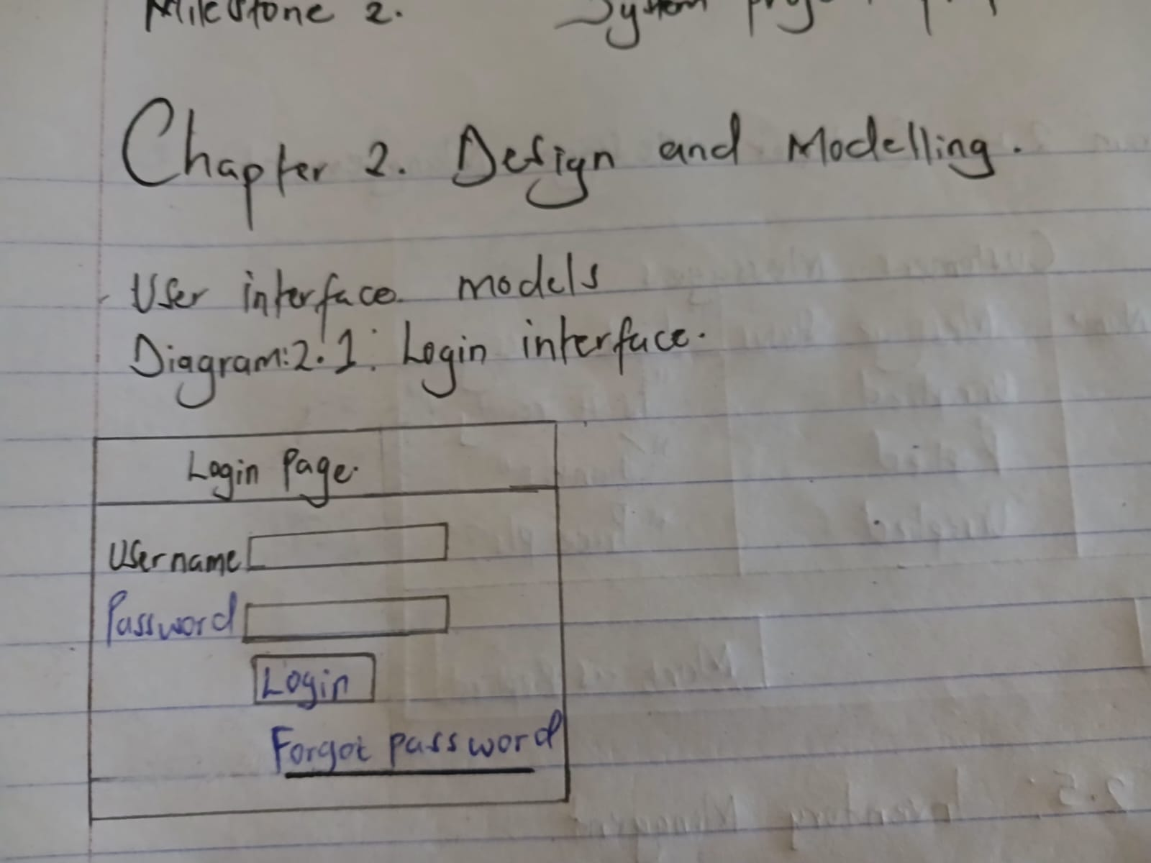
Figure 2.1: Login Page Interface

Diagram 2: Dashboard Interface
Explanation:
The dashboard provides an overview of the system. It displays key information such as total orders, pending orders, completed orders, and low-stock alerts. This helps the student quickly understand the current business status without checking messages manually.
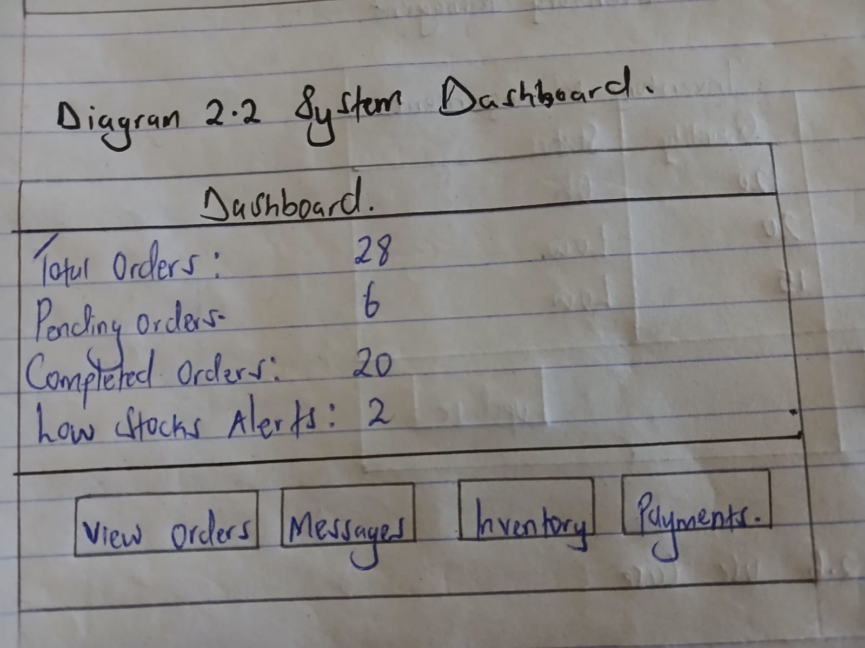
Figure 2.2: System Dashboard

Diagram 3: Order Management Page
Explanation:
This diagram shows the order management page where the student can view all customer orders. Each order includes customer details, necklace type, quantity, payment status, and order status. This reduces confusion and prevents mixing up orders.
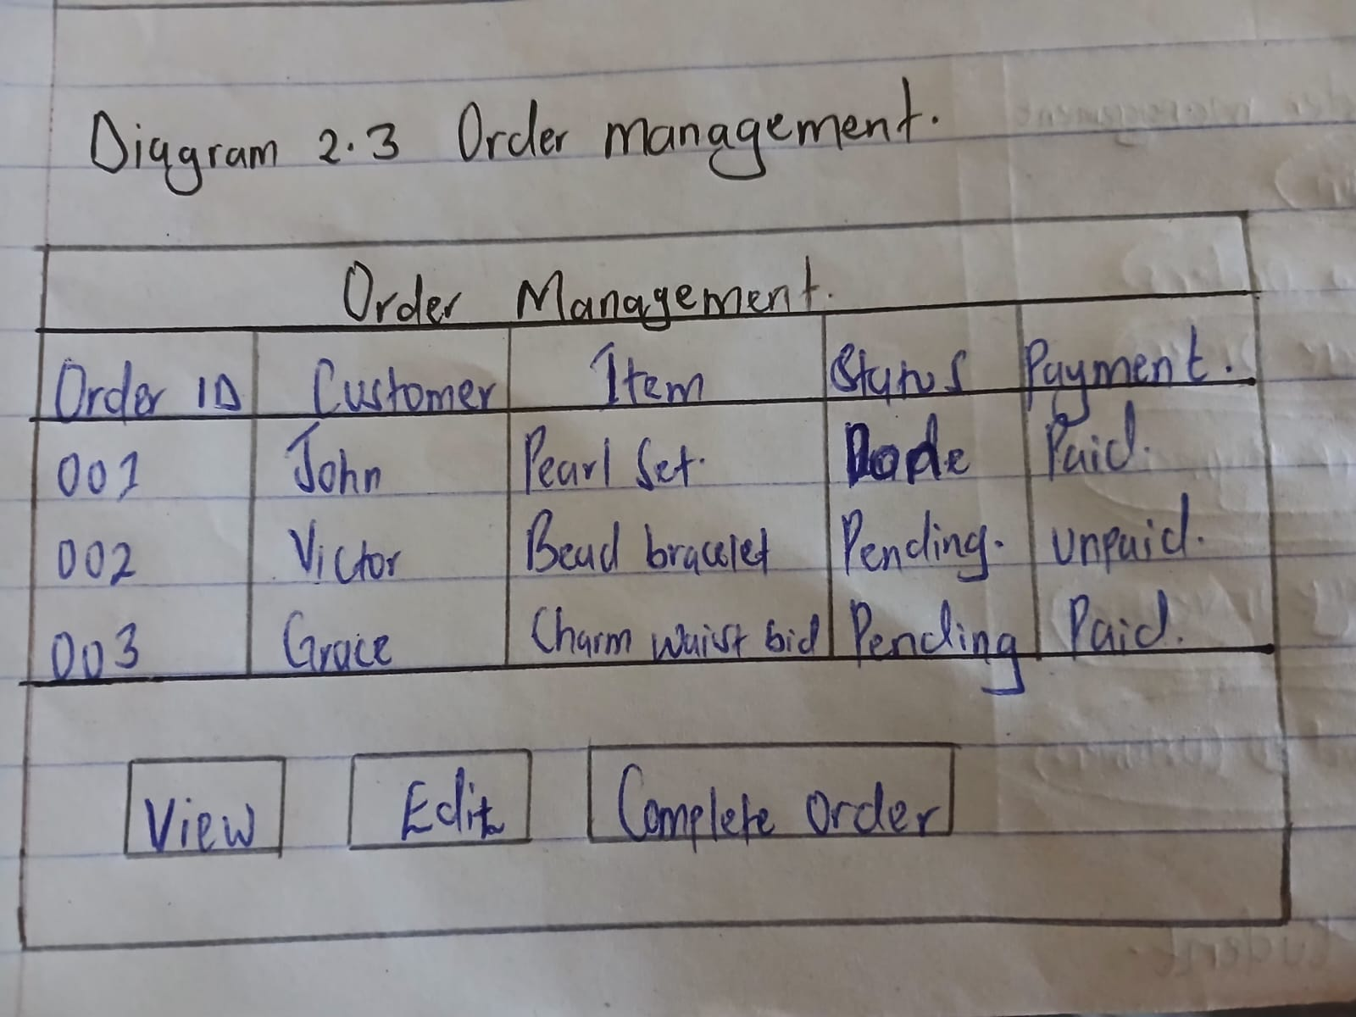
Figure 2.3: Order Management Interface

Diagram 4: Customer Messages Interface
Explanation:
This interface displays customer inquiries and messages in an organized manner. Instead of replying manually on Instagram, messages are stored and tracked within the system, reducing the chances of forgetting to respond to customers.
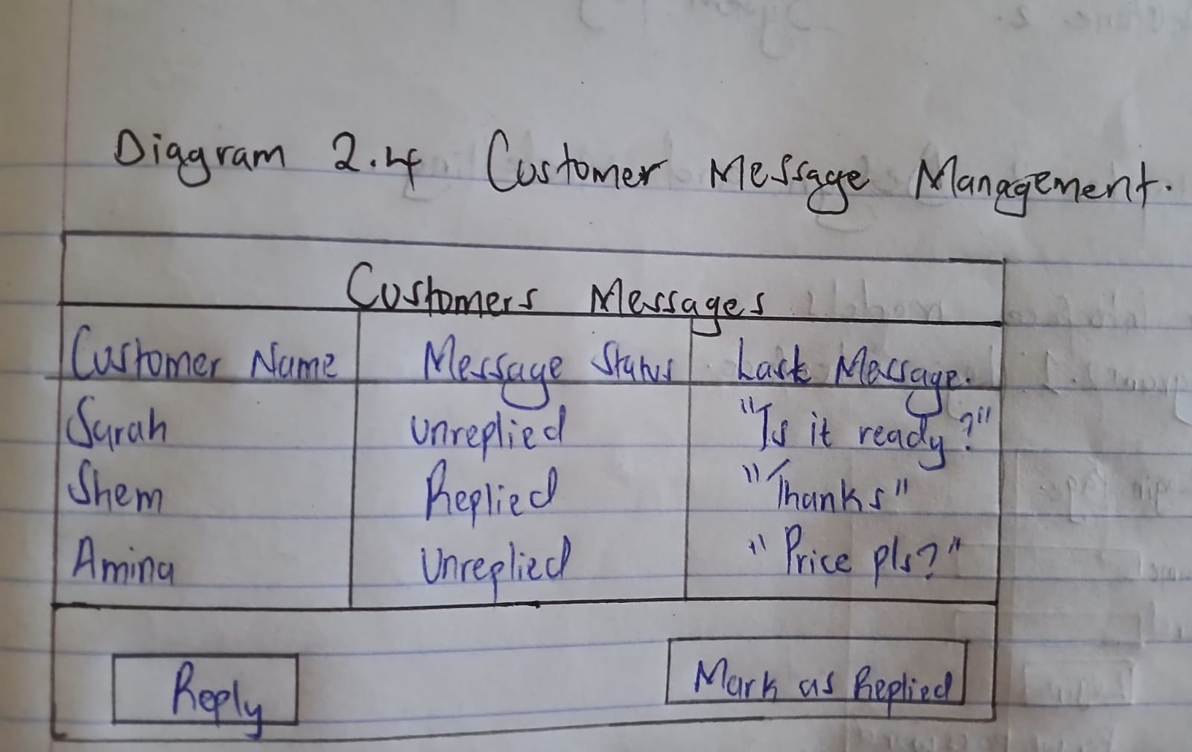
[Image: Customer Message Management Interface]
Figure 2.4: Customer Message Management Interface

Diagram 5: Inventory Management Interface
Explanation:
This diagram represents the inventory page where the student can track available materials such as beads, strings, and clasps. The system alerts the user when materials are running low, helping prevent delays in order fulfillment.
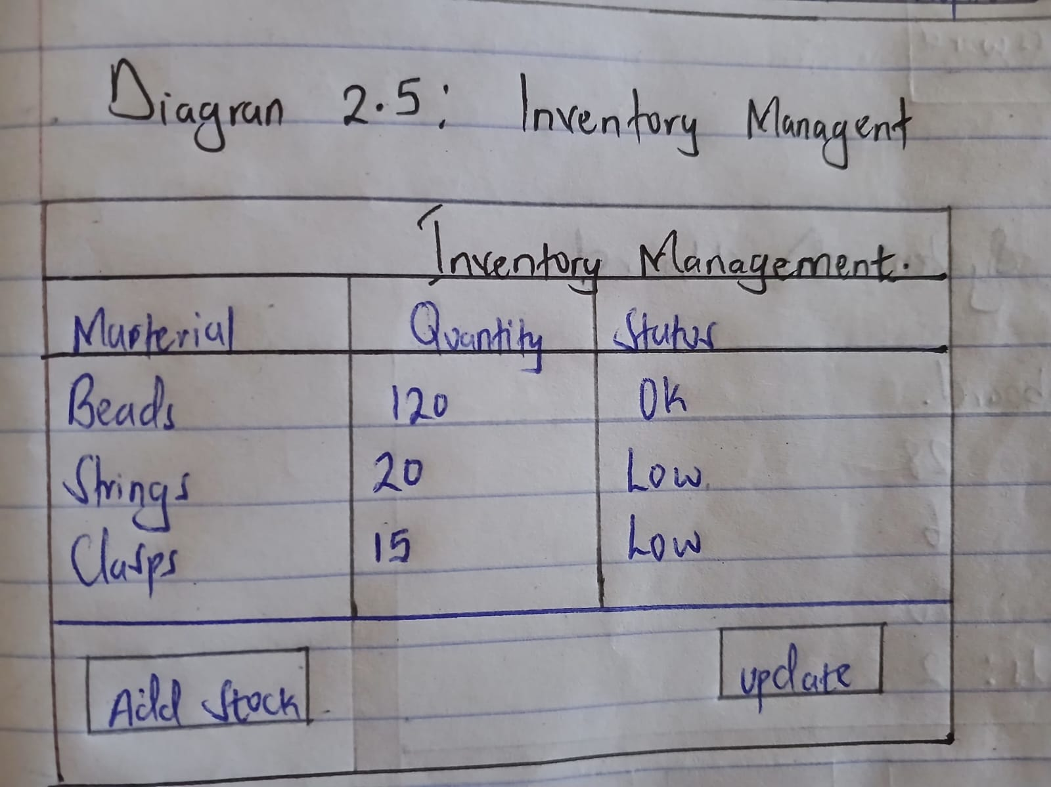
Figure 2.5: Inventory Management Interface

2.3 Logic Models
2.3.1 Login Process Flowchart
This flowchart describes the security gateway for the system, ensuring only authorized users gain access.
- Start & Input: The process begins when the user triggers the login action and enters their unique Username and Password.
- Decision (Validation): The system checks the provided credentials against the database.
- Error Path: If the details are incorrect, the system displays an Error Message, prompting the user to try again.
- Success Path: If the details are correct, the system proceeds to Open the Dashboard, granting the user access to the system’s features.

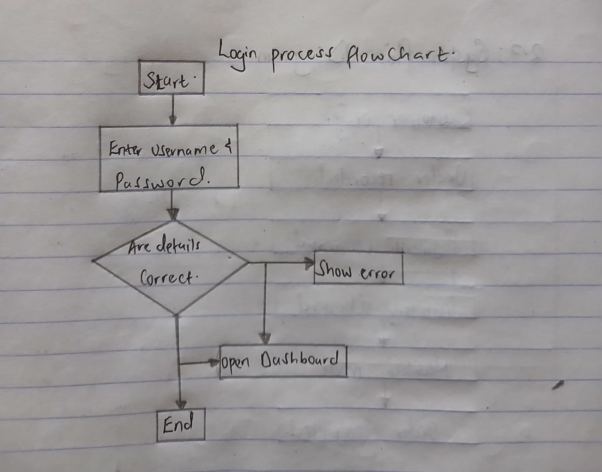
Figure 2.3.1: Flowchart illustrating the user authentication and dashboard access process.

2.3.2 Order Process Flowchart
This diagram outlines the journey from a customer’s initial interest to the completion of a physical product.
- Order Entry: The process starts when a Customer Places an Order.
- Payment Confirmation: The system checks if the payment is confirmed. If “No,” the system Notifies the Customer of the failure and ends the process.
- Stock Check: If payment is successful, the system checks if the necessary raw materials or stock are Available.
- Production: Once stock is confirmed, the workflow moves to the manufacturing phase (Make Necklace).
- Fulfillment: Finally, the Order Status is Updated, the order is marked as Complete, and the process ends.
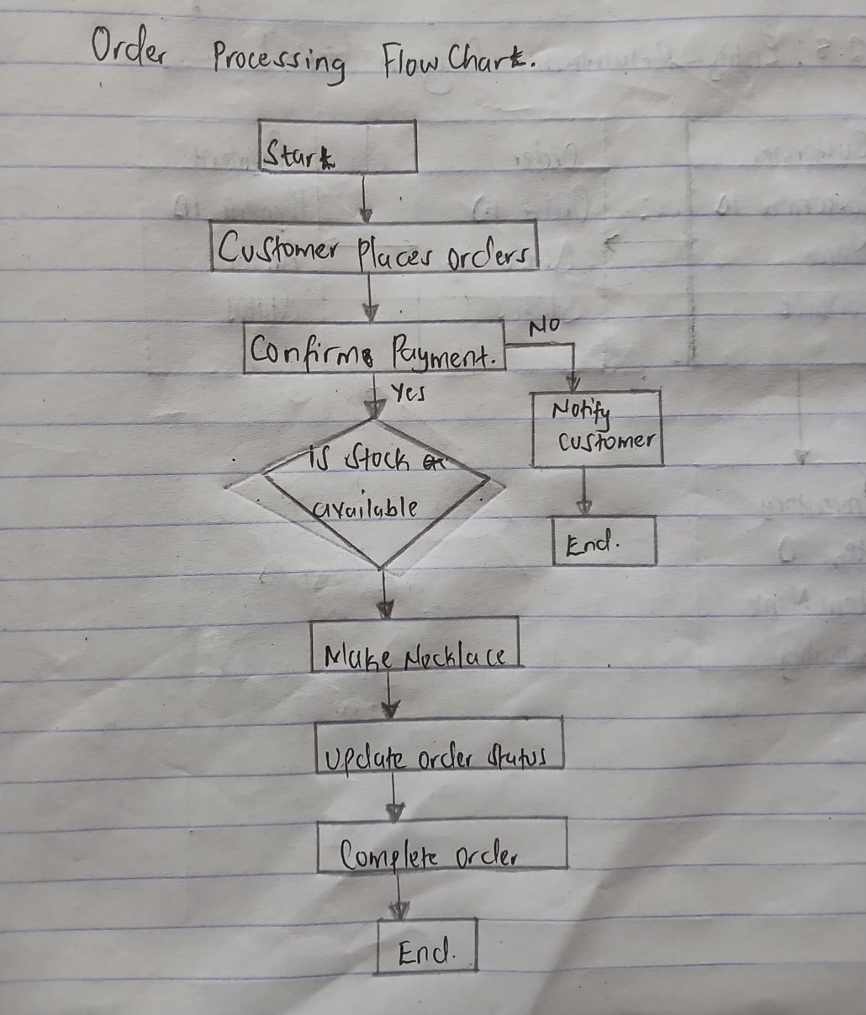
Figure 2.3.2: Flowchart representing the customer ordering, payment confirmation, and manufacturing steps

2.3.3 Payment Processing Flowchart
This section focuses specifically on the financial transaction logic within the system.
- Data Collection: The system Receives Payment Details (e.g., credit card info or bank transfer data).
- Validation: A verification step occurs to ensure the account has sufficient funds and the data is valid.
- Success Logic: If successful, the system Records the Payment in the ledger and updates the transaction status to “Paid.”
- Failure Logic: If the payment fails, the status is updated to “Pending,” allowing for a later retry or manual intervention before ending.
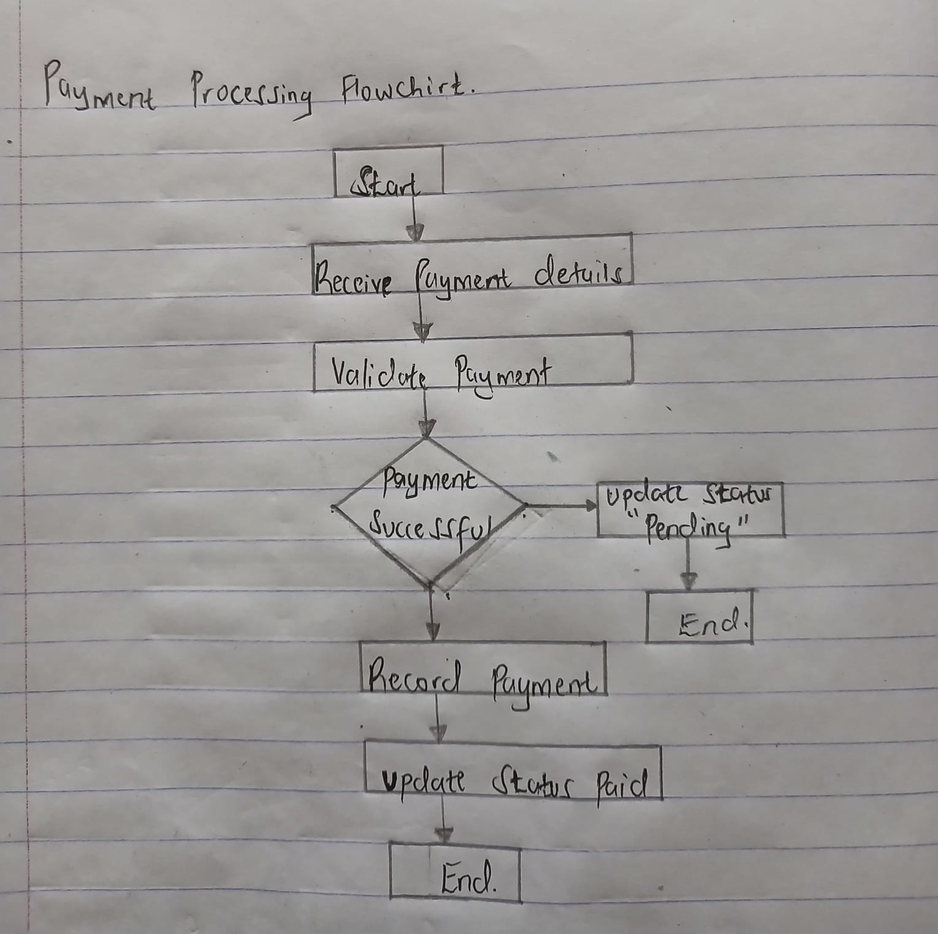
Figure 2.3.3: Detailed view of payment validation and status recording.

2.3.4 Inventory Management Flowchart
This is a background process designed to maintain supply chain efficiency.
- Monitoring: The system initiates a Check of Inventory Levels for materials.
- Threshold Decision: The system asks: “Is stock below reorder level?”
- Action: If the stock is too low, the system automatically Generates a Low Stock Alert to notify the manager to restock. If the stock is sufficient, the process ends without further action.
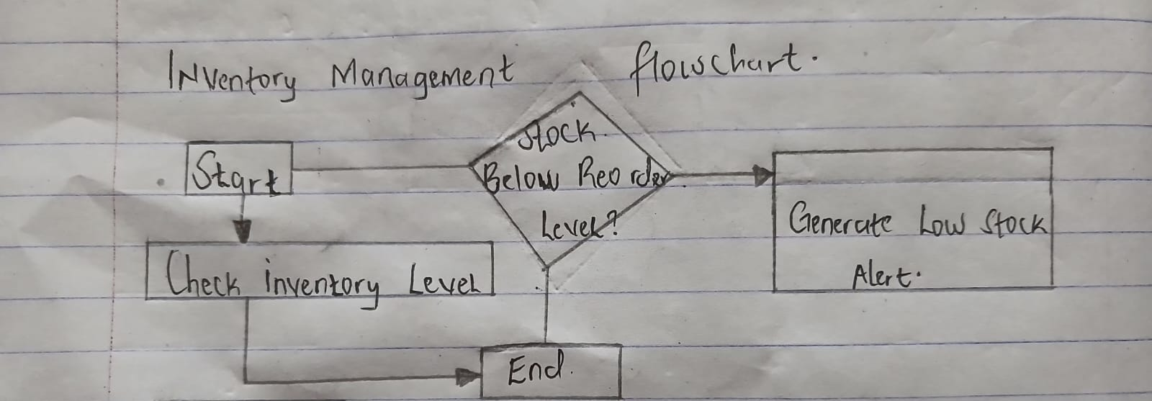
Figure 2.3.4: Automated check for stock reorder levels and alert generation.

2.3.5 From Enquiry Making to Enquiry Reply Flowchart
This flowchart manages the communication loop between the customer and the support/student team.
- Submission: The process is triggered when a Customer Sends a Message.
- Storage: The message is saved in the database (Store Message).
- Review: A student or administrator Reviews the Message to determine the appropriate response.
- Status Update: If a Reply is Sent, the status is updated to “Replied.” If no reply has been sent yet, the status remains “Pending.”
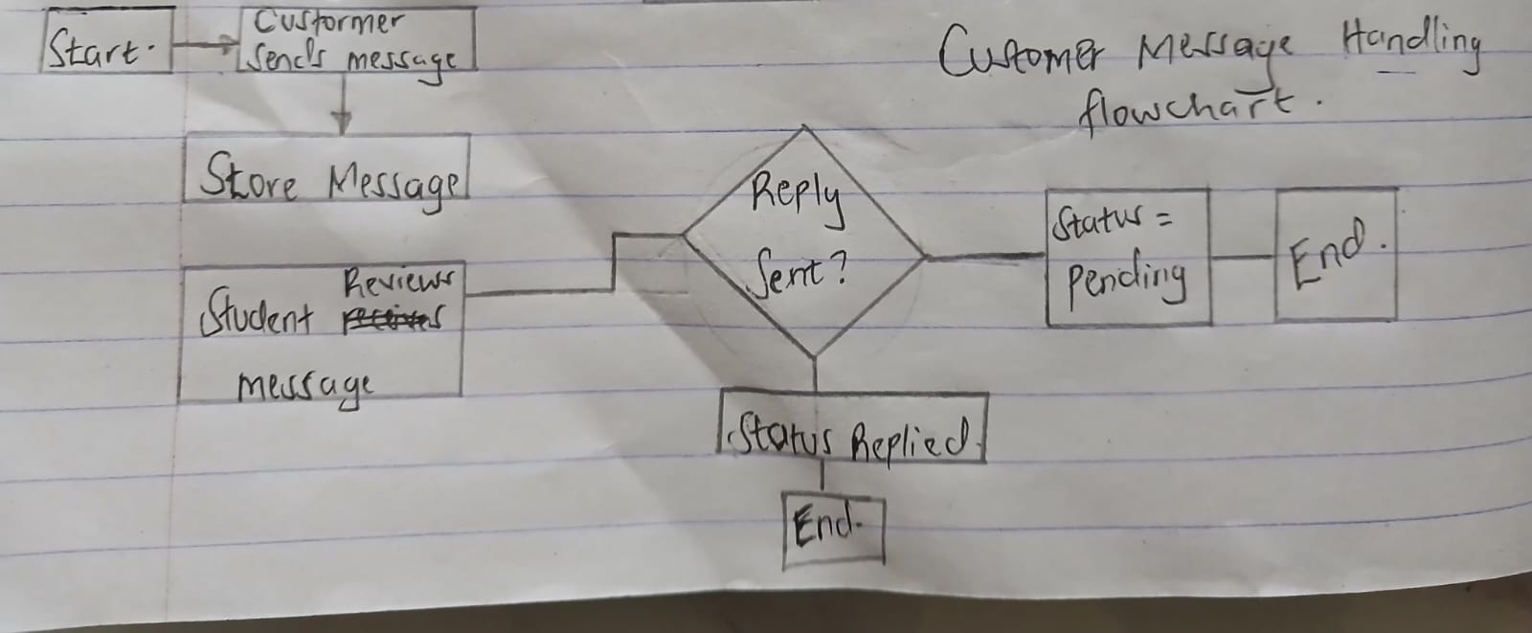
Figure 2.3.5: Process flow for receiving, reviewing, and replying to customer inquiries.

Diagram 6: Use Case Diagram
Explanation:
The use case diagram shows how the student interacts with the system. It includes actions such as managing orders, replying to customers, tracking payments, and managing inventory.
Actors: Student (System User)
Use Cases: Login, View Orders, Manage Orders, Track Payments, Manage Inventory, Respond to Customers
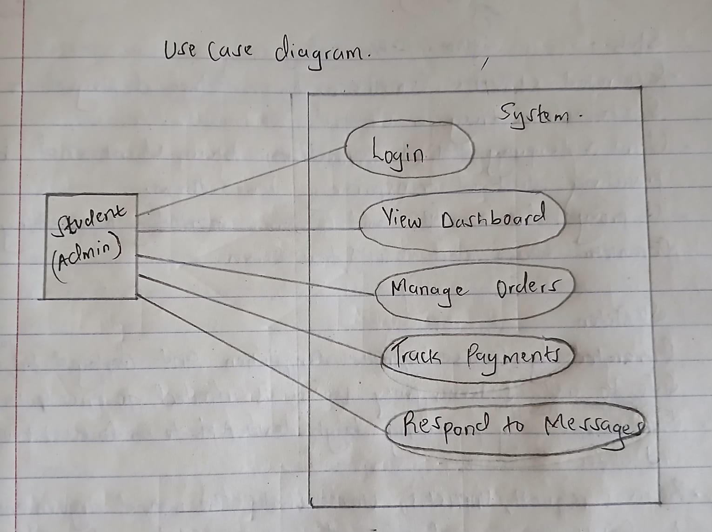
Figure 2.6: Use Case Diagram for the Order Management System

Diagram 7: System Flow Diagram (Process Flow)
Explanation:
This diagram illustrates the flow of activities from receiving a customer order to completing it. It shows steps such as order placement, payment confirmation, inventory checking, necklace creation, and order completion.
Flow Example:
Customer Order → Order Recorded → Payment Confirmed → Inventory Checked → Necklace Made → Order Completed
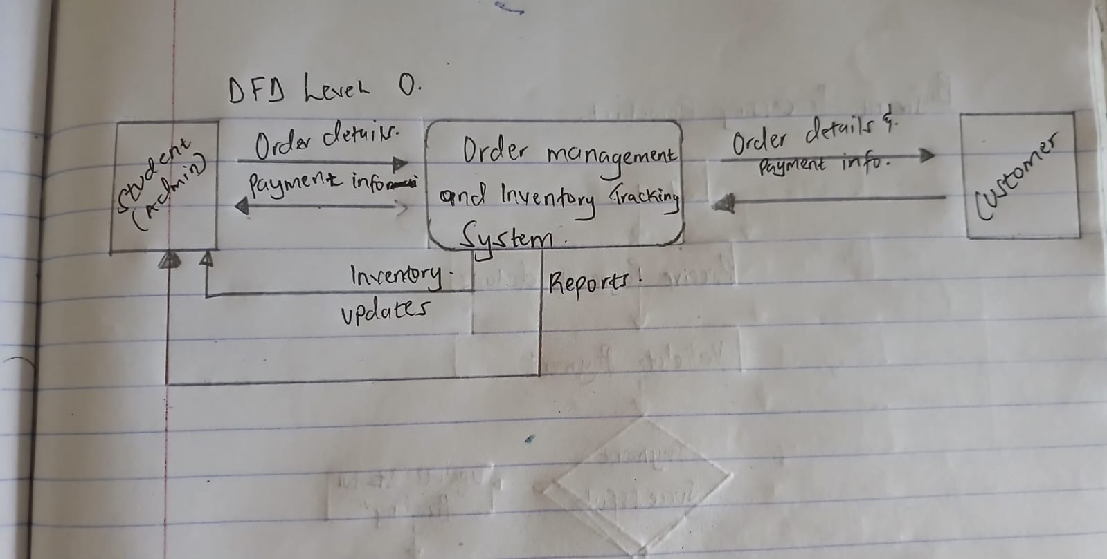
Figure 2.7.1: System Flow Diagram

Diagram 8: Data Flow Diagram (Level 1)
The diagram represents the Data Flow Diagram (DFD) Level 1 of the Necklace Order Management System. It shows how data moves within the system between external entities, processes, and data stores.
The Customer sends order details, which are handled by the Manage Orders (1.0) process and stored in D1 – Orders. The Payment Process (2.0) retrieves order and customer information, processes payments, updates D2 – Payments, and adjusts D4 – Inventory. The Student (Admin) interacts with the Generate Reports (2.0) process to obtain system reports based on stored data.
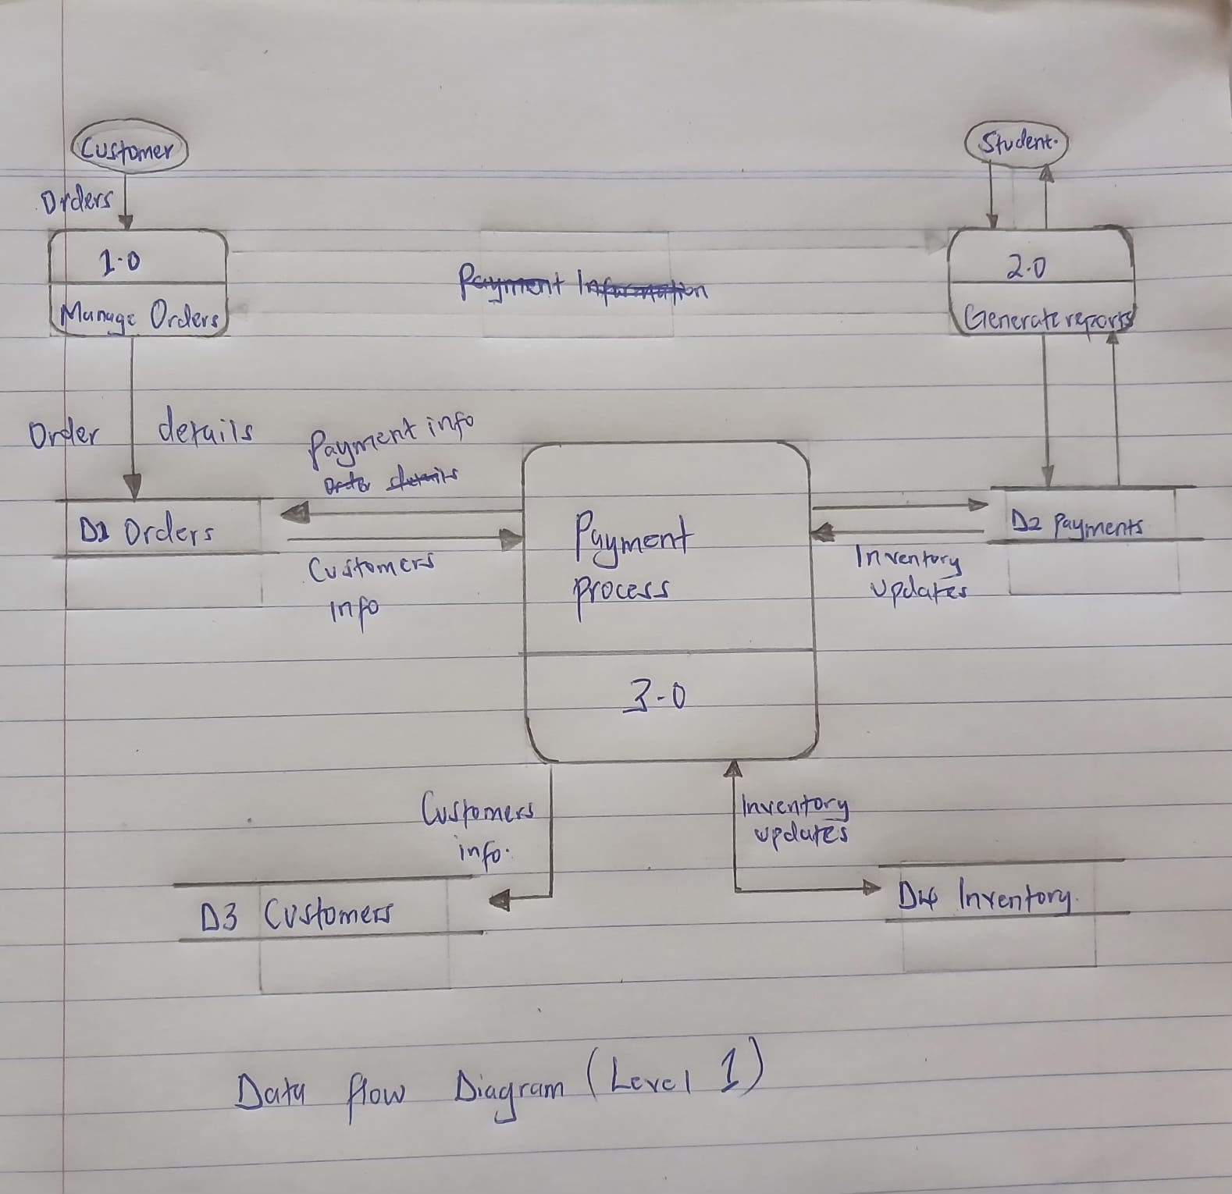
Figure 2.7.2: Data Flow Diagram (Level 1)

2.4 Entity Relationship Diagram (ERD)
Explanation:
The ERD shows how data is stored and related within the system. Entities include Customer, Order, Payment, and Inventory.
Explanation of Relationships:
- Customer to Order (1:M): One customer can place multiple orders over time, but each specific order is linked to one unique customer ID.
- Order to Payment (1:1): For each order, there is a corresponding payment record to track the financial status (e.g., Paid, Unpaid).
- Order to Inventory (M:M via Recipe): An order consists of products, and each product requires specific materials (beads, clasps) from the inventory. The “Recipe” entity acts as a bridge to ensure the correct amount of stock is deducted for each necklace made.
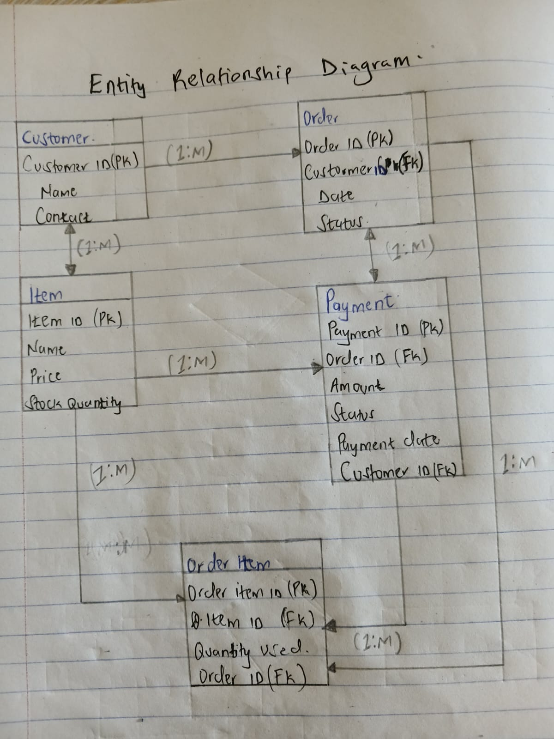
Figure 2.8: Entity Relationship Diagram

CHAPTER THREE: SYSTEM IMPLEMENTATION
3.1 Introduction
This chapter provides a detailed account of the development journey for the Order Management and Inventory Tracking System. It tracks the process from the initial setup of the development environment to the coding of the user interfaces and back-end logic, concluding with the testing and deployment phases. The goal is to demonstrate how the conceptual designs from the previous chapters were transformed into a functional cloud-based application using modern web technologies.
3.2 User Interface Development
The system’s front end was developed using HTML5, CSS3, and JavaScript (ES6+) to ensure a responsive and dynamic user experience. Visual Studio Code (VS Code) served as the primary IDE for writing and managing this code.
3.2.1 Login Page Development
The Login Page serves as the security gateway for the system. It was built to ensure that only the authorized artisan can access sensitive business data such as customer orders and inventory levels.
- Code Details: The interface uses an HTML form to capture the username and password, with CSS used to style the input fields and “Login” button for a professional look.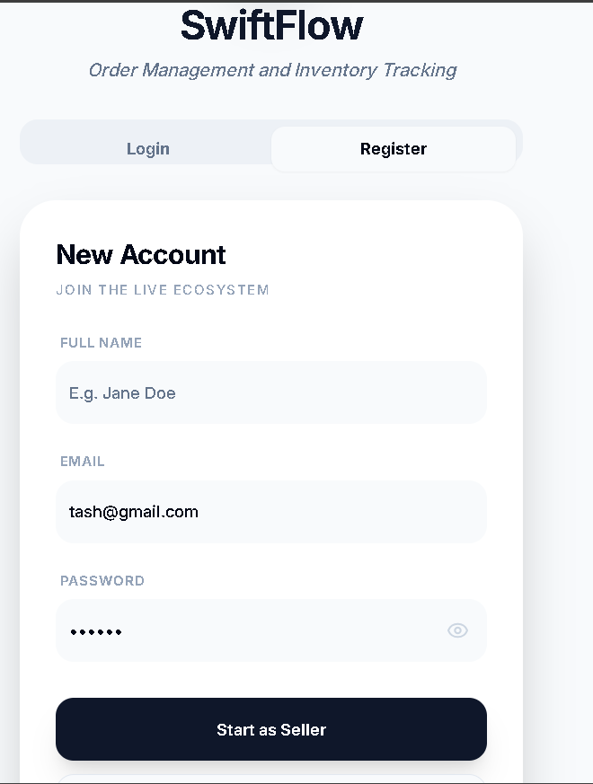a professional look.

Figure 3.1: HTML and CSS Source Code for Login Interface.

3.2.2 Dashboard Development
The Dashboard is the central hub of the application, providing real-time summaries of total orders, pending tasks, and low-stock alerts.
- Function: It uses JavaScript to fetch data from Firebase Firestore and display it dynamically.
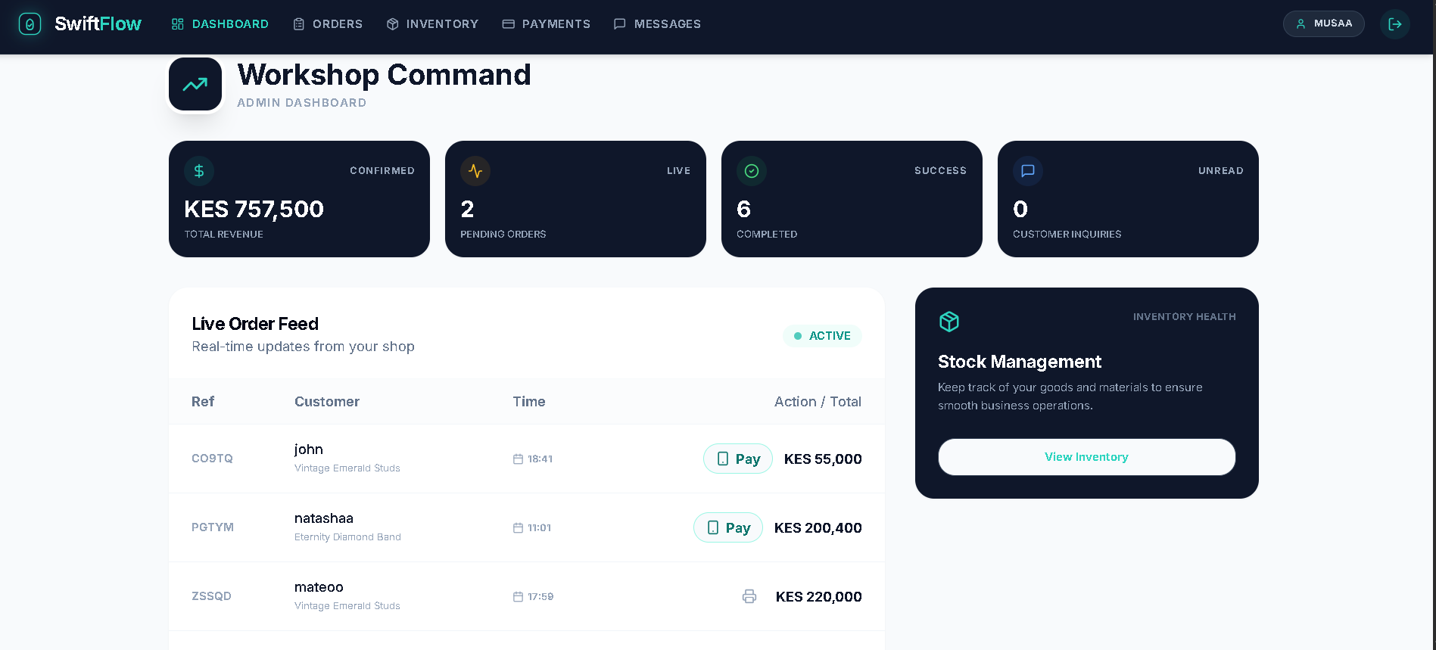
Figure 3.2: System Dashboard Interface showing business health metrics.

3.2.3 Inventory Management Interface
This interface allows for the tracking of raw materials such as beads, strings, and clasps.
- Function: It includes forms to add new materials and a table to display current stock levels, with automated alerts for items below the reorder threshold.
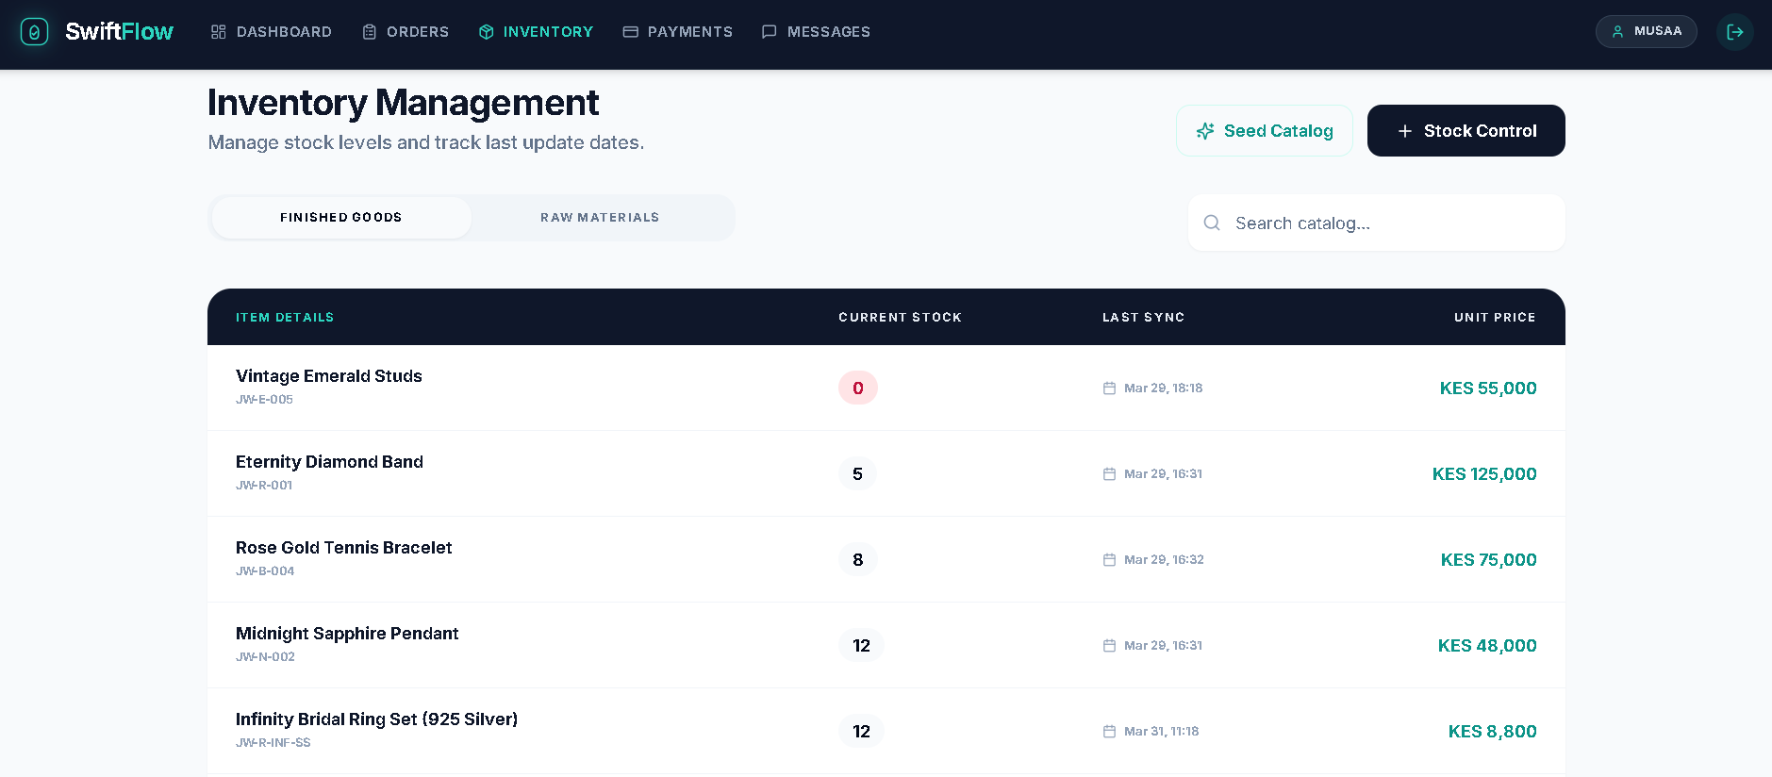
Figure 3.3: Inventory Tracking Interface with low-stock notification triggers.
3.3 Logic Development
The “logic side” handles the processing of data and interactions with the database.
3.3.1 Authentication Logic
Using Firebase Authentication, the system validates user credentials. If the login details match the stored records, the system grants access; otherwise, it returns an error message.
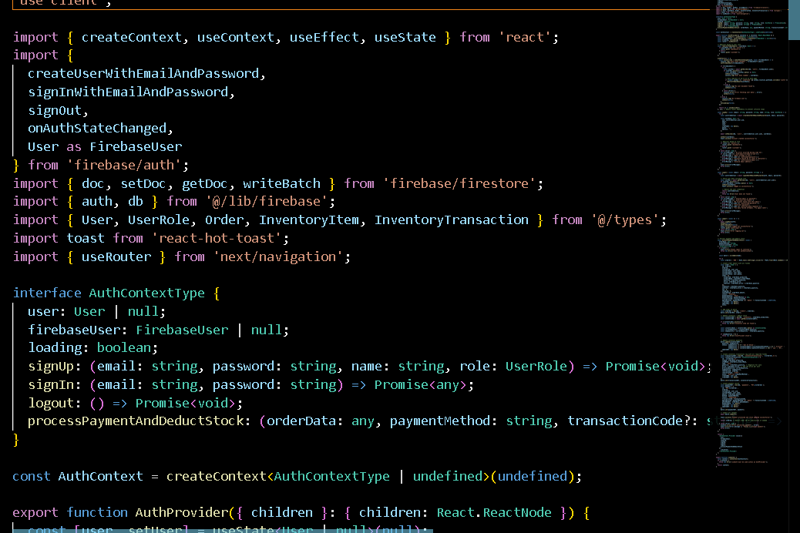
Figure 3.4: JavaScript Logic for Firebase User Authentication.
3.4 Testing
Testing was conducted to ensure the system met the functional requirements, such as order recording and stock tracking.
- Unit Testing: Individual components like the login form and “Add Material” button were tested to ensure they captured data correctly.
- User Acceptance Testing (UAT): A group of jewelry artisans and peers tested the UI/UX to provide feedback on the system’s ease of use.
- Correction: During testing, an error in the stock alert logic was identified where alerts triggered too late; this was corrected by adjusting the threshold variable in the code.
3.5 Deployment
The system was deployed using Firebase Hosting, which provides a live, secure URL for the web application. After completion, the system was deployed live, providing a working URL.
- Process: The project was initialized using the Firebase CLI, and the “build” folder containing the HTML/CSS/JS/TypeScript files was deployed to the cloud.
- Live Link: https://swift-flow-delta.vercel.app/

CHAPTER FOUR: CONCLUSION AND RECOMMENDATION

4.1 Conclusion
This project involved the planning, design, and implementation of a centralized Order Management and Inventory Tracking System for social-media-driven micro-enterprises. Chapter One established the need for automation to replace manual DM-based tracking. Chapter Two modeled the system architecture, and Chapter Three detailed the successful implementation using the Firebase stack.
Through this journey, I learned the importance of full-stack development and the complexities of real-time data synchronization. The primary challenge was integrating the manual workflow of jewelry making into a structured digital format. The final system successfully addresses the core problems of fragmented order management and inventory tracking, providing a scalable solution for student entrepreneurs.

4.2 Recommendations
To further enhance the system, future developers could consider integrating an automated payment system such as an M-PESA API to enable real-time payment confirmation, reducing the need for manual status updates. Additionally, while the current system is a responsive web application, developing a native mobile application using React Native would provide better offline access for artisans working in various locations with inconsistent internet connectivity. Future versions could also incorporate advanced analytics by utilizing a NoSQL approach to store and analyze customer feedback patterns, which could help suggest new product designs based on emerging trends. Lastly, implementing multi-user support with role-based access control would allow the system to scale as the business grows beyond a single entrepreneur to include multiple staff members.

REFERENCES
Firebase. (2024). Cloud Firestore documentation: Real-time data for modern apps. Google Cloud. https://firebase.google.com/docs/firestore
Google Gemini. (2024). Conversation on developing an automated order and inventory management system for handmade jewelry artisans. [Generative AI].
Laudon, K. C., & Laudon, J. P. (2022). Management Information Systems: Managing the Digital Firm (17th ed.). Pearson.
React Native. (2024). Core components and APIs: Building mobile interfaces. Meta Open Source. https://reactnative.dev/docs/components-and-apis
Shopify. (2023). The maker’s guide to inventory management: How to track beads, gems, and supplies. Shopify Business Blog. https://www.shopify.com/blog/inventory-management
Wix Engineering. (2024). Scaling micro-enterprise operations through automated order tracking. Wix Technical Blog.
Zetech University. (2026). *System documentation template (Jan-Apr 2026)*. [Internal Course Material].

